GUI Interaction Services
Chapter
5

uicUnitControlT

Requirements

Logical Design

Static Models

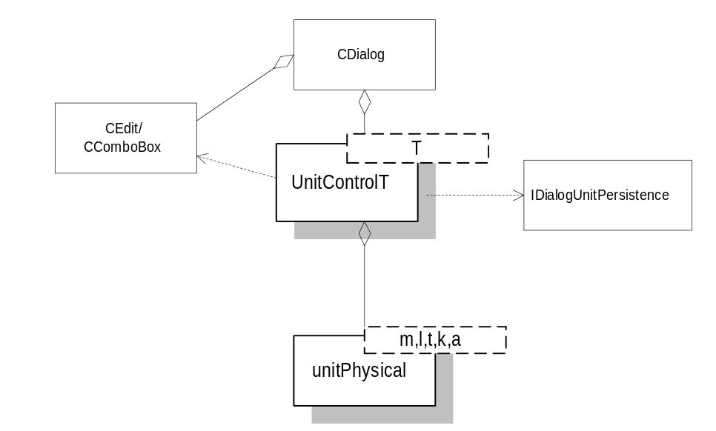

Physical Design

Specifications

UnitControlT
Helper class for creating a specialized CEdit/CComboBox unit control. Noted functions are required to be called from the parent dialog in order to obtain minimum functionality. Refer to the User’s Guide for more information.

Public Interface - Member Functions
Constructor
uicUnitControlT(const std::vector<const T*>& units, CWnd* pDlg, int dlgId, int editCtrlId, int comboCtrlId)
Constructor using template argument which will typically be some derivative of unitPhysicalT. Pass in vector of units to be used in control and Id's of the parent Dialog, Edit box and Combo Box. The default unit becomes the first unit in the units list. Call SetDialogUnitPersistence to set up persistence for this control.
Destructor
virtual ~uicUnitControlT()
OnInitDialog - Required
void OnInitDialog()
Call from parent dialogs OnInitDialog method. Sets up the combo box with the correct text strings and possibily pointers to the physical unit objects.
DoDataExchange - Required
void DoDataExchange(CDataExchange* pDX,double* pValue)
Instead of writing custom DDX methods, the data exchange stuff can be completely encapsualted within this class.pValue is a pointer to the value of the control in system units.
OnSelChangeUnits - Required
void OnSelChangeUnits()
Call this routine from your handler for the CBN_SELCHANGE message for your unit pair’s ComboBox.
SetDialogUnitPersistence
void SetDialogUnitPersistence(psgIDialogUnitPersistence* pMapper)
Set up persistence. This should be done once only soon after construction. This class does not take responsibility for lifetime ownership of the pointer. If this function is not called, the control always defaults to the first unit in the vector passed into the constructor.
EnableBoundsChecking
void EnableBoundsChecking(double lowerBound, double upperBound)
Enables bounds checking on the two values specified in system units.
DisableBoundsChecking
void DisableBoundsChecking()
Disables bounds checking for the control
IsBoundsCheckingEnabled
bool IsBoundsCheckingEnabled()
Check to see if bounds checking is enabled
SetUnitOfMeasureIndex
void SetUnitOfMeasureIndex(int comboIdx, bool bConvert)
Sets the unit of measure for the edit/combo control. If bConvert is true, the current value in the edit control is converted to the new unit of measure.
SetUnitOfMeasureString
void SetUnitOfMeasureString(std::string& name, bool bConvert)
Sets the unit of measure for the edit/combo control. If bConvert is true, the current value in the edit control is converted to the new unit of measure.
GetUnitOfMeasureIndex
int GetUnitOfMeasureIndex()
Returns the combobox index for the current unit of measure
GetUnitOfMeasureString
std::string GetUnitOfMeasureString()
Returns the unit tag string for the current unit of measure

IDialogUnitPersistance
Pure abstract interface class for supporting persistance for uicUnitControlT class.

Public Interface - Member Functions
SetLastUnit
virtual void SetLastUnit(int dlg,int ctrl,const std::string& unit)=0;
Used by uicUnitControlT to save off the unit tag string for the control prior to destruction. The int’s passed in are the control id’s for the dialog and the control, respectively.
GetLastUnit
virtual std::string GetLastUnit(int dlg,int ctrl)=0;
Get the last used units for the dialog widget. Returns an empty string if it fails to retrieve a default.

